Problem 3 – Kukata is Dancing

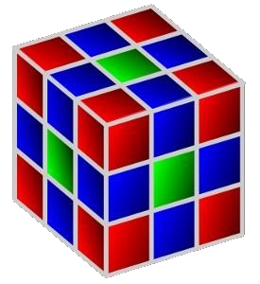
“The Hook” (also known as Kukata) is a very famous Sofia Gangster. He is wanted for various crimes like drugs distribution, counterfeiting of credit cards and also breaking a bottle in a guy’s neck while screaming “Eiiii murshiiiiiii”. But the real passion of Kukata is the dancing, especially on top of cubes. And today he is dancing on a very special cube. It is of size 3x3x3 and there are nine squares on each of its six sides. Each side is colored according to the following rules:
- The four squares at the corners are red.
- The center square on each side is green.
- All of the remaining squares are blue.
Each dance of Kukata always begins from the green square on the top side of the cube and he is looking at one of the blue squares. Kukata knows only three dance moves, but he can do them flawlessly:
- ‘L’ – He stays in the current square and turns 90 degrees to the left.
- ‘R’ – He stays in the current square and turns 90 degrees to the right.
- ‘W’ – He walks on the next square in the current direction.
Please keep in mind that Kukata is a great dancer and he can cross an edge of the cube into another side. If that happens, the cube automatically rotates to keep him on top. You will receive a sequence of all movements made by Kukata. You should evaluate them and return the color of the last square that Kukata is standing on.

Input
The input data should be read from the console. On first input line you will receive an integer number N, showing the number of performed dances. On each of the next N lines you will receive a string containing only the letters ‘L’, ‘R’ and ‘W’ which will refer to the sequence of moves. The input data will be correct and there is no need to check it explicitly.

Output
The output data should be printed on the console. On the N output lines you should print one of the words “RED”, “GREEN”, “BLUE” (without the quotes), showing the color of the last square of the dance.

Constraints
- N will be between 5 and 10 inclusive.
- The input strings will contain between 1 and 50 characters, inclusive.
- The input strings will contain only the letters ‘L’, ‘R’ and ‘W’.
- The answer will not depend on the initial direction of Kukata.
- Allowed working time for your program: 0.1 seconds. Allowed memory: 16 MB.

Examples
Example input | Example output
5  LLRR  WWWWWWWWWWWW  WLWRW  WWL  LWRL | GREEN  GREEN  RED  BLUE  BLUE
Example input | Example output
5  WWRLLW  RWLW  WWL  W  LWWW | RED  RED  BLUE  BLUE  GREEN

